**Call For Code 2019 - < For_The_Cause > Deadline – 06/07/2019**

**Project Title**

*Eagle-eye*

**Project Description**

*The main aim is to detect the forest fire, calculate the growth rate and direction of the wildfire. , A surveillance drone integrated with camera, GSM and GPS module which can get us real time images, One the fire is detected the all the required authority will be immediately informed. The drone can also provide virtual network, the people who are in the forest at that time can easily connect with our network and get the real time data of the fire, drown will map the whole area and will get the most safe route for evacuation.*

*We have used IBM-Watson Visual Recognition for detection of wildfire and not just a campfire. We are trying built a model, which can tell us the movement of fire and the rate of growth also by including the weather data.*

**Current Problem -**

*In the situation of fire, it becomes very important to properly map the affected area and the area can get affected, also to locate the human population inside forest.*

**Solution Description -**   
*The Idea is to create a Forest Fire detection system, a surveillance drone integrated with camera, GSM and GPS module. In case of fire, this drone will get us the real time pictures of that area, with the help of IBM-Watson Visual Recognition we will process the image, and create a model that shows with which rate the fire is growing and the direction too. This module is integrated with real time weather data from backend to get the wind speed and direction of the wind, humidity level, temperature etc. This drown will help in evacuation of the people who are in the forest at that time and at the same time will inform the government authority, fire department thought message alert. The drown will be capable of providing good network in the forest at critical time along with it people can connect with our virtual network and we’ll map the area and provide them shortest path to evacuate.*

**Included Components -**

1. *IBM-Watson visual Recognition*
2. *Drone integrated with camera, GSP and GPS module*
3. *Real time weather data.*

**Featured Technologies -**

1. *Image processing*
2. *AI which can create most precise model of movement of forest-fire*
3. *GPS network provided*

**Architecture Diagram -**  
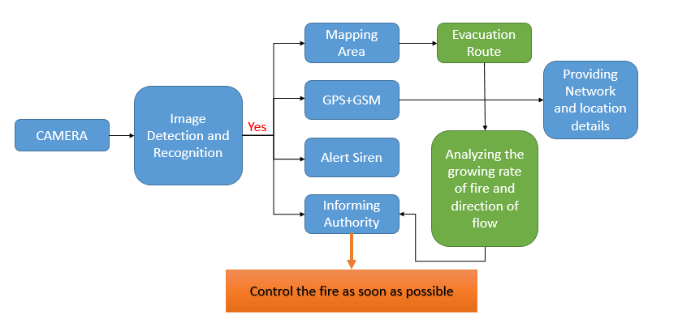

**Steps -**

* *Whenever there is a fire, first the drone will take a list of images to get the best evidence, it’s a forest fire and not just dummy.*
* *One the forest fire is detected the drone will blow a loud alert siren.*
* *Immediately notify the authority with an alert message and location.*
* *Map the whole area to create the growth rate model*
* *Create a VPN so that people inside forest can connect to the network and get the real time data and evacuation route*

**Results -**

*The forest-fire/ Wildfire leads to a great loss to environment, animals living the forest and leads to many human life. If can somehow instantly surrender the fire will greatly help in saving many life.*

*AIM is to use the best of the available technology integrate it and bring out best for Society.*